30 mph limit in place at last!

After many accidents over the years, making Ford Street somewhat of a blackspot a 30mph limit is now in place.

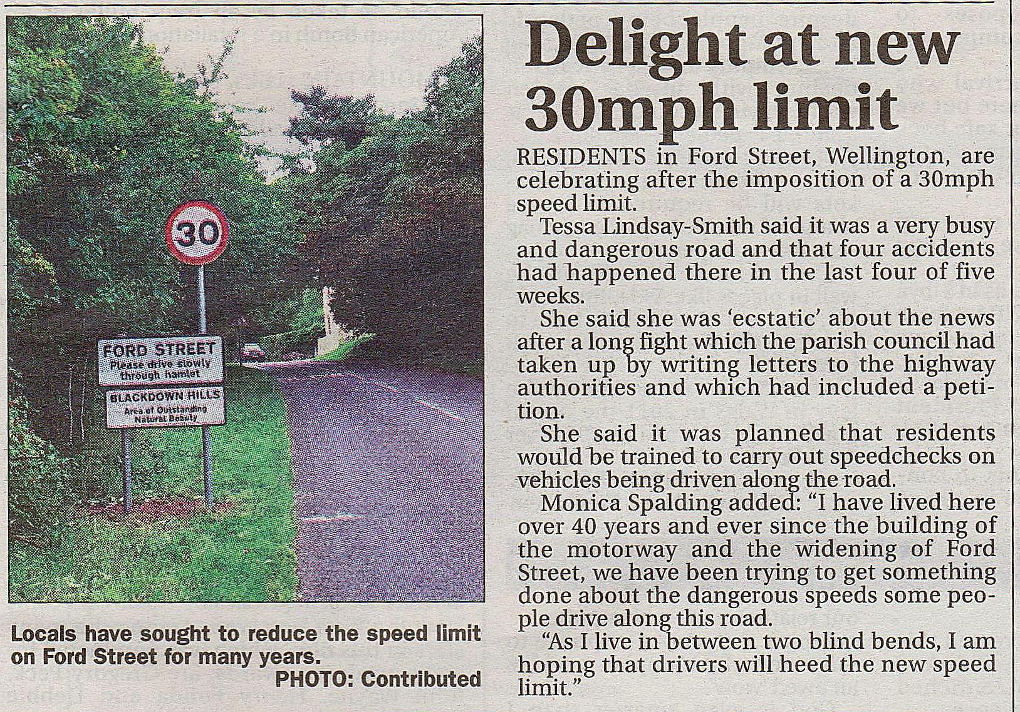

Excerpt from the Wellington Weekly News September 23rd 2015