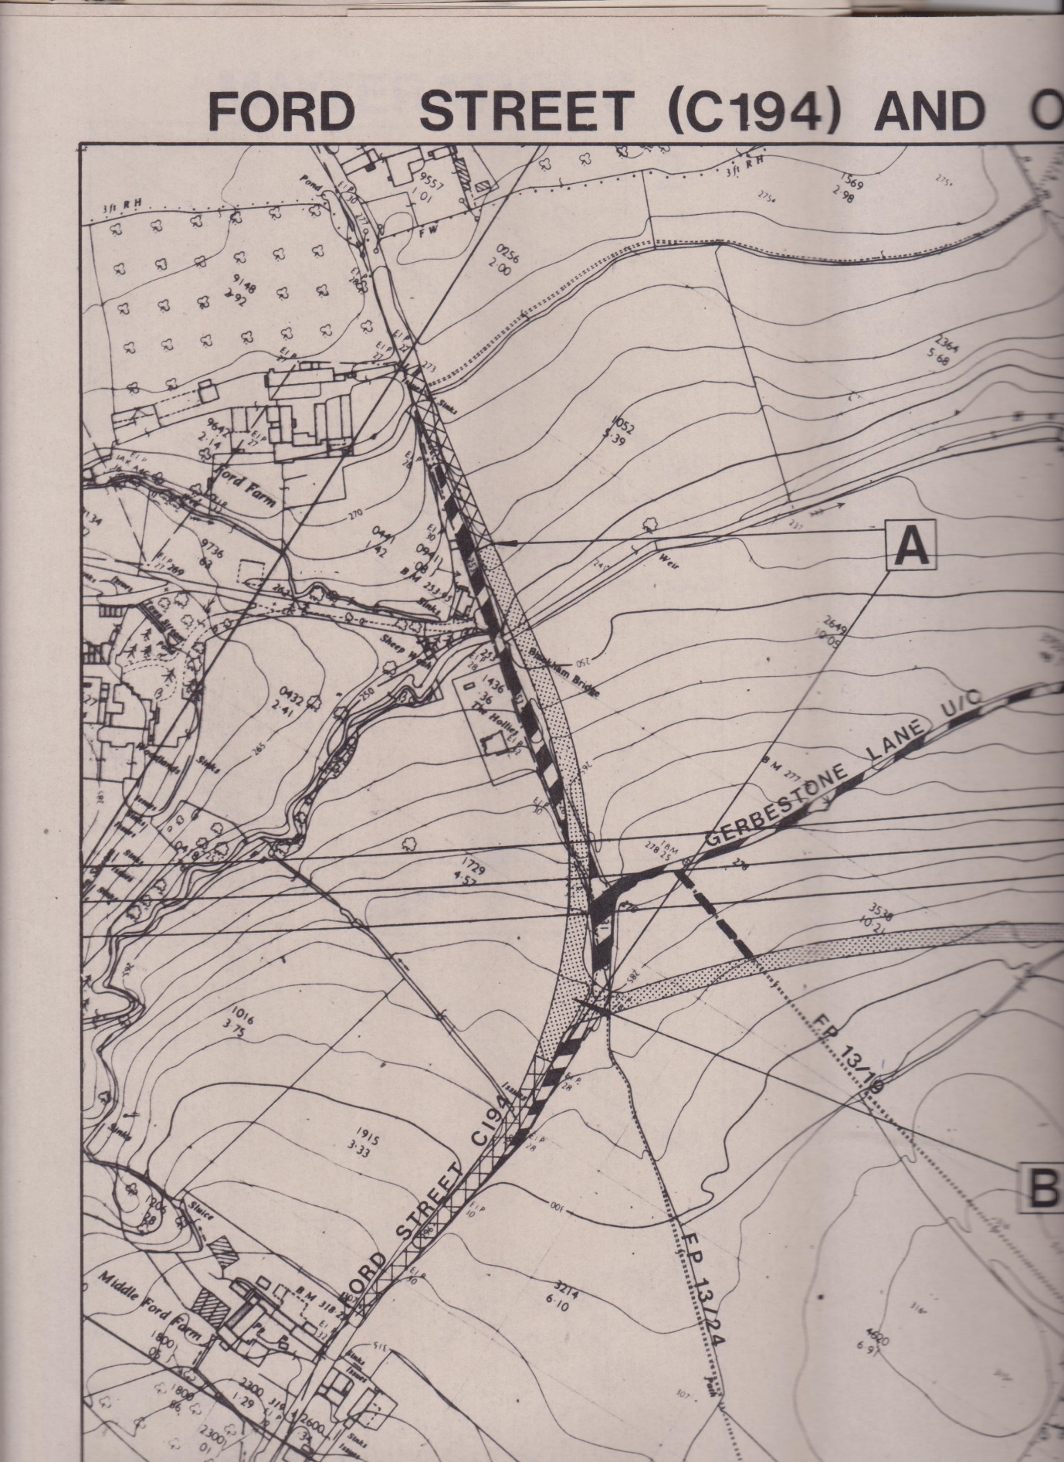

Gerbestone Road realignment when the M5 was constructed: sheet 1 of 2