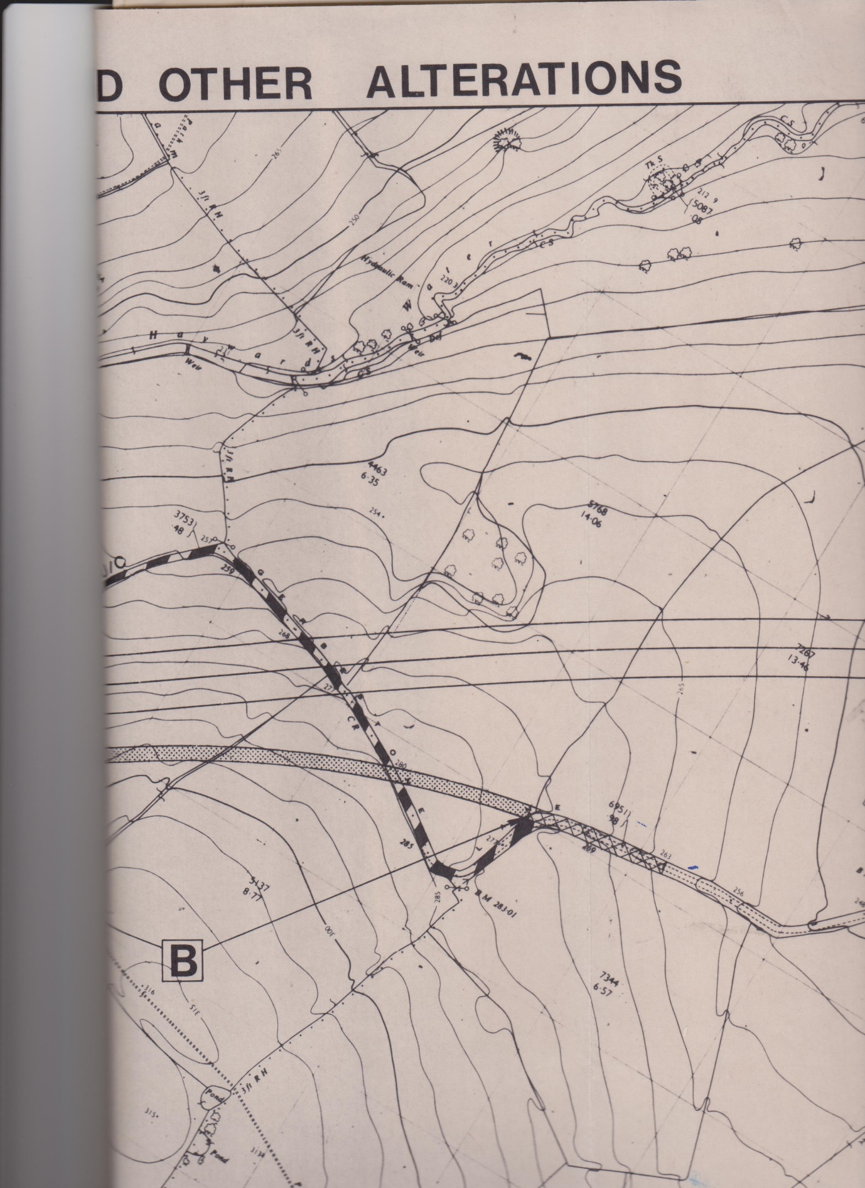

Gerbestone Road realignment when the M5 was constructed: sheet 2 of 2