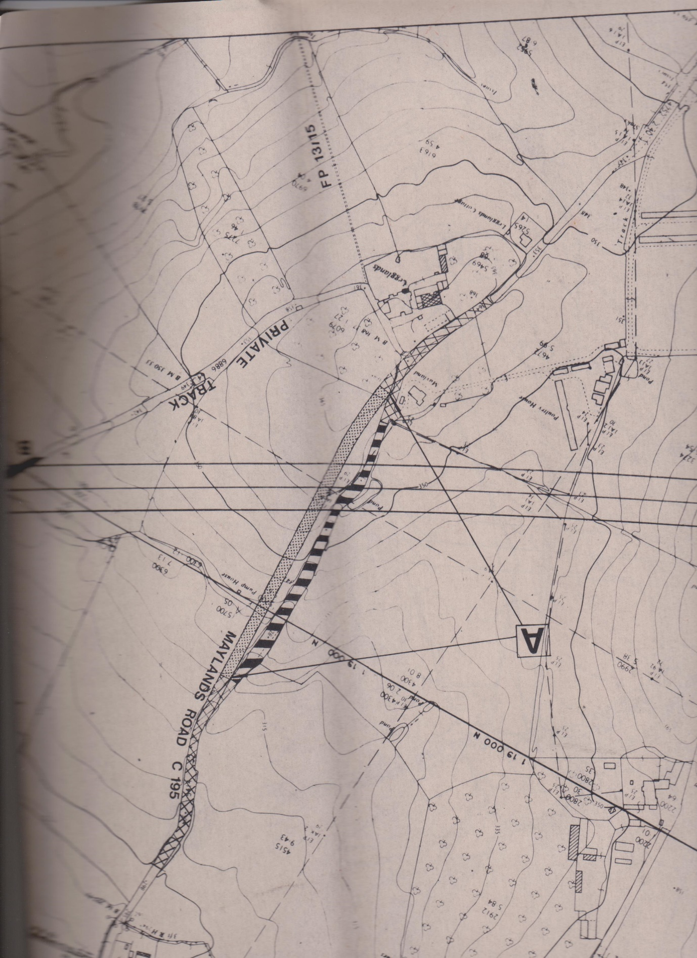

Planned realignment of Maylands Road during M5 construction