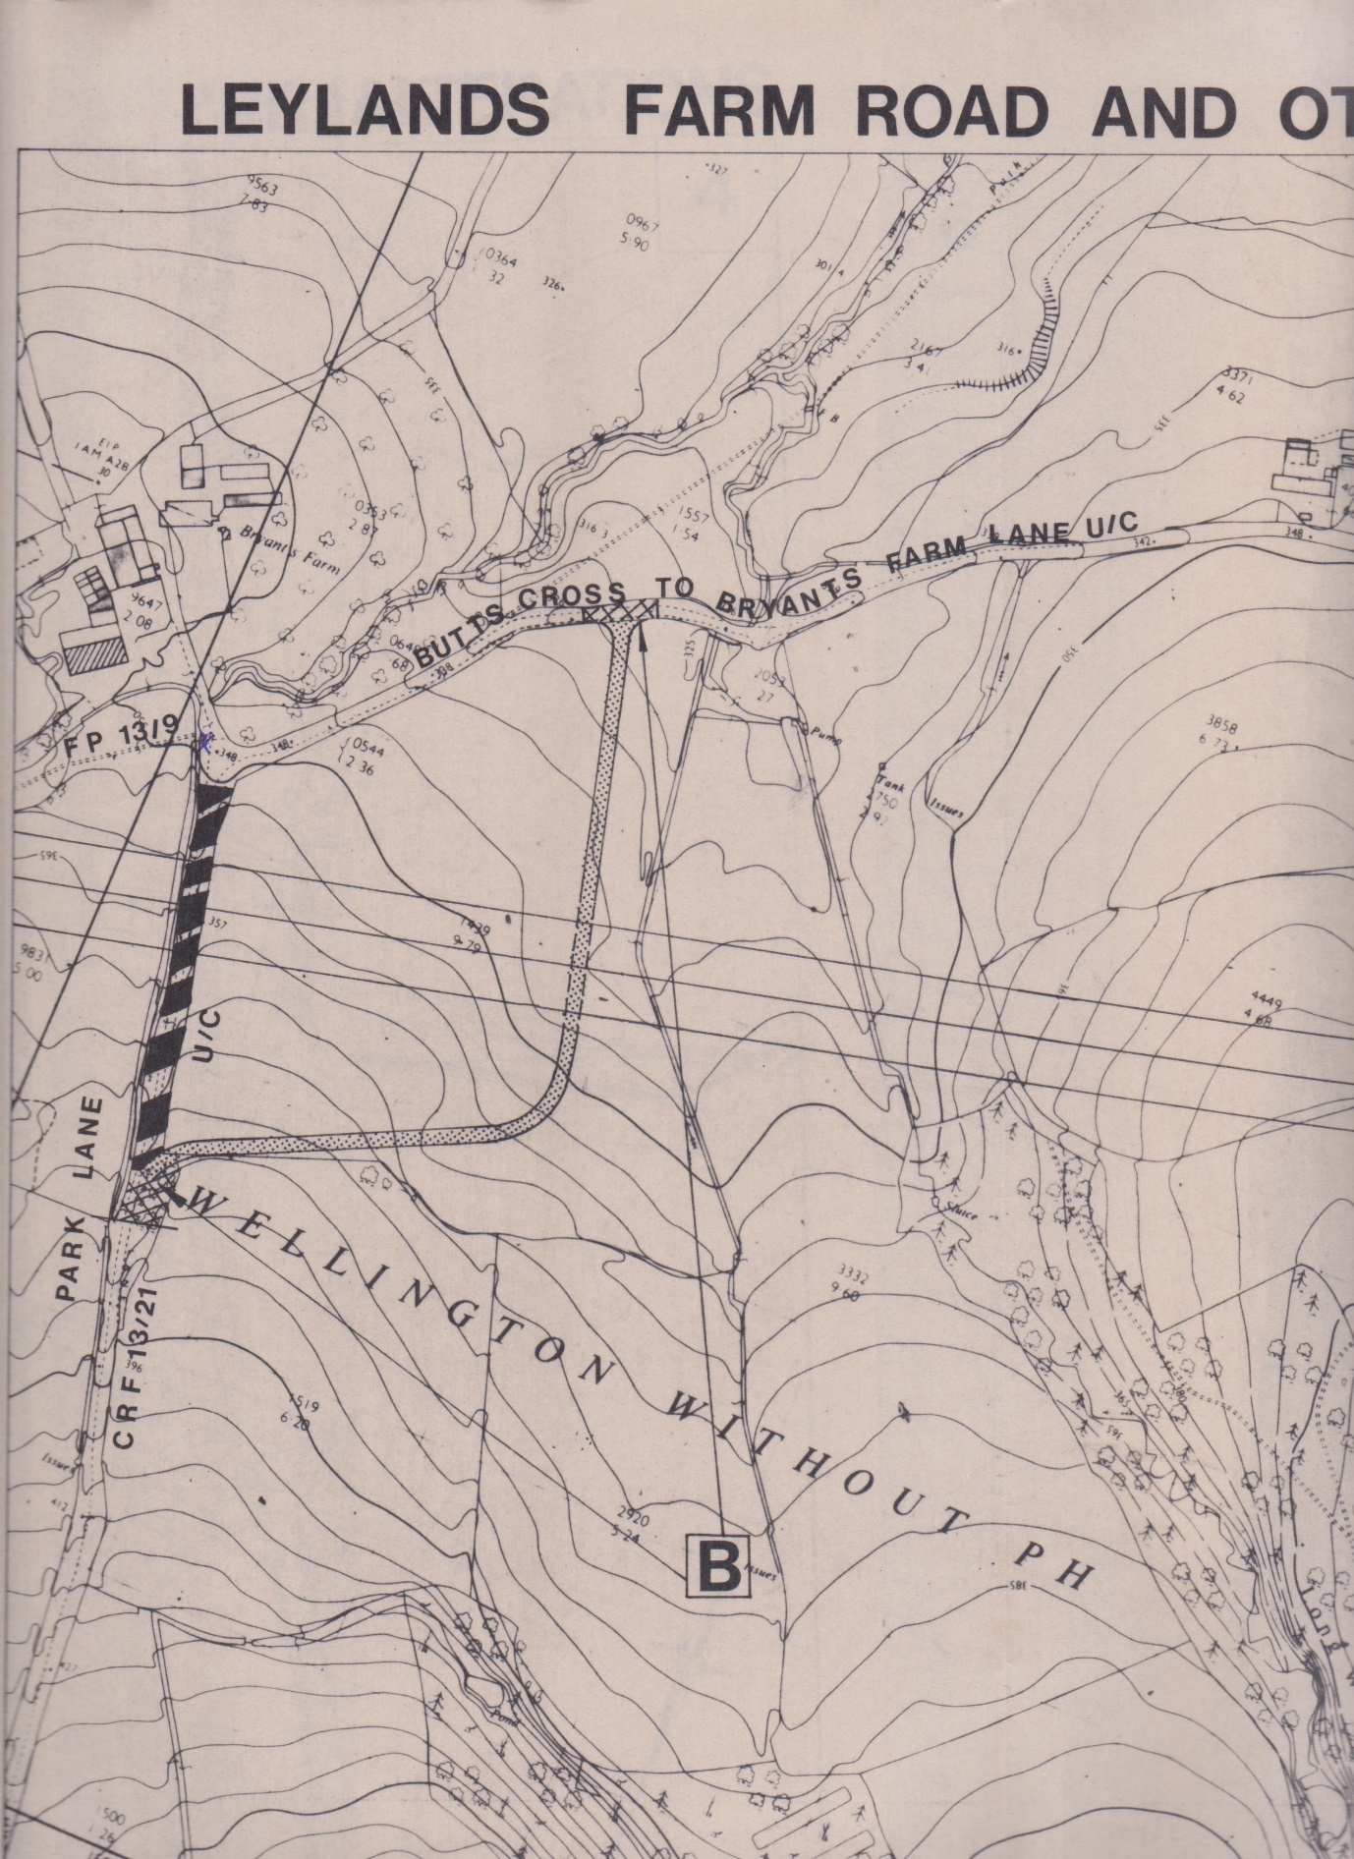

Planned realignment of Park Lane during M5 construction