Repainted finger post

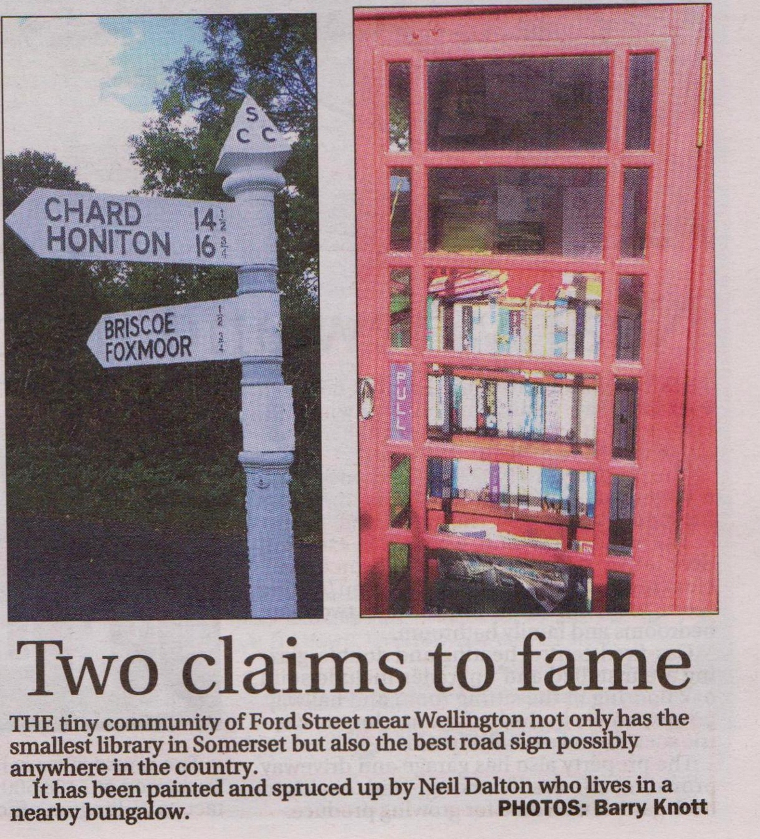

Excerpt from the Wellington Weekly News 30th September 2015