Speedwatch Training at the Beam Bridge Inn January 2016

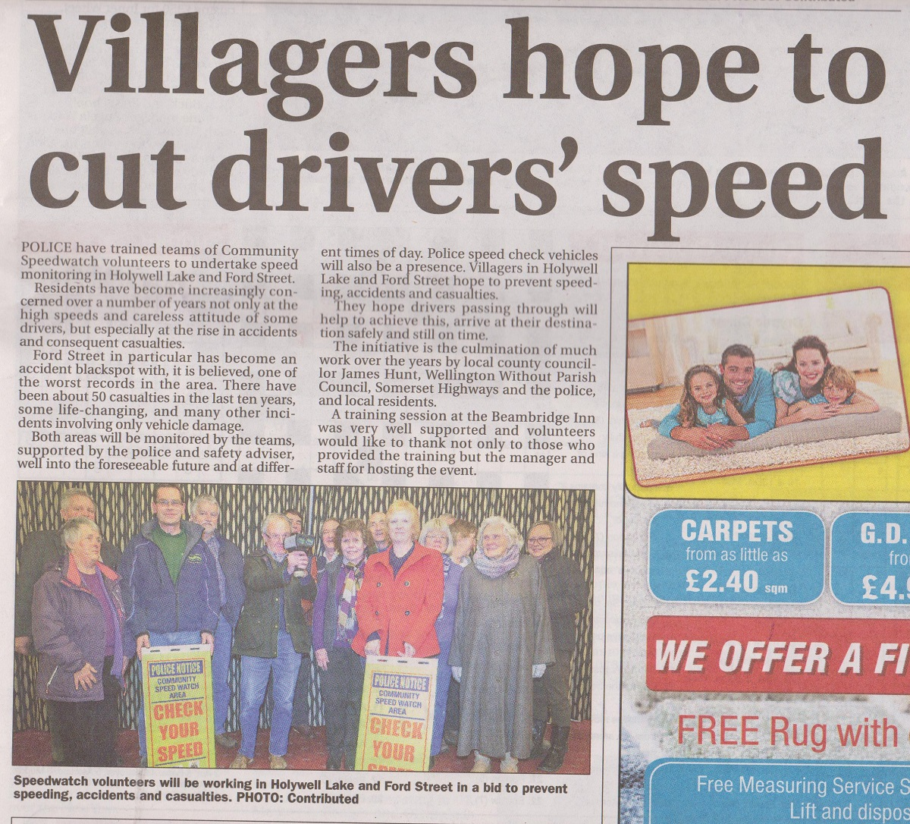

Extract from the Wellington Weekly on the 20th January 2016