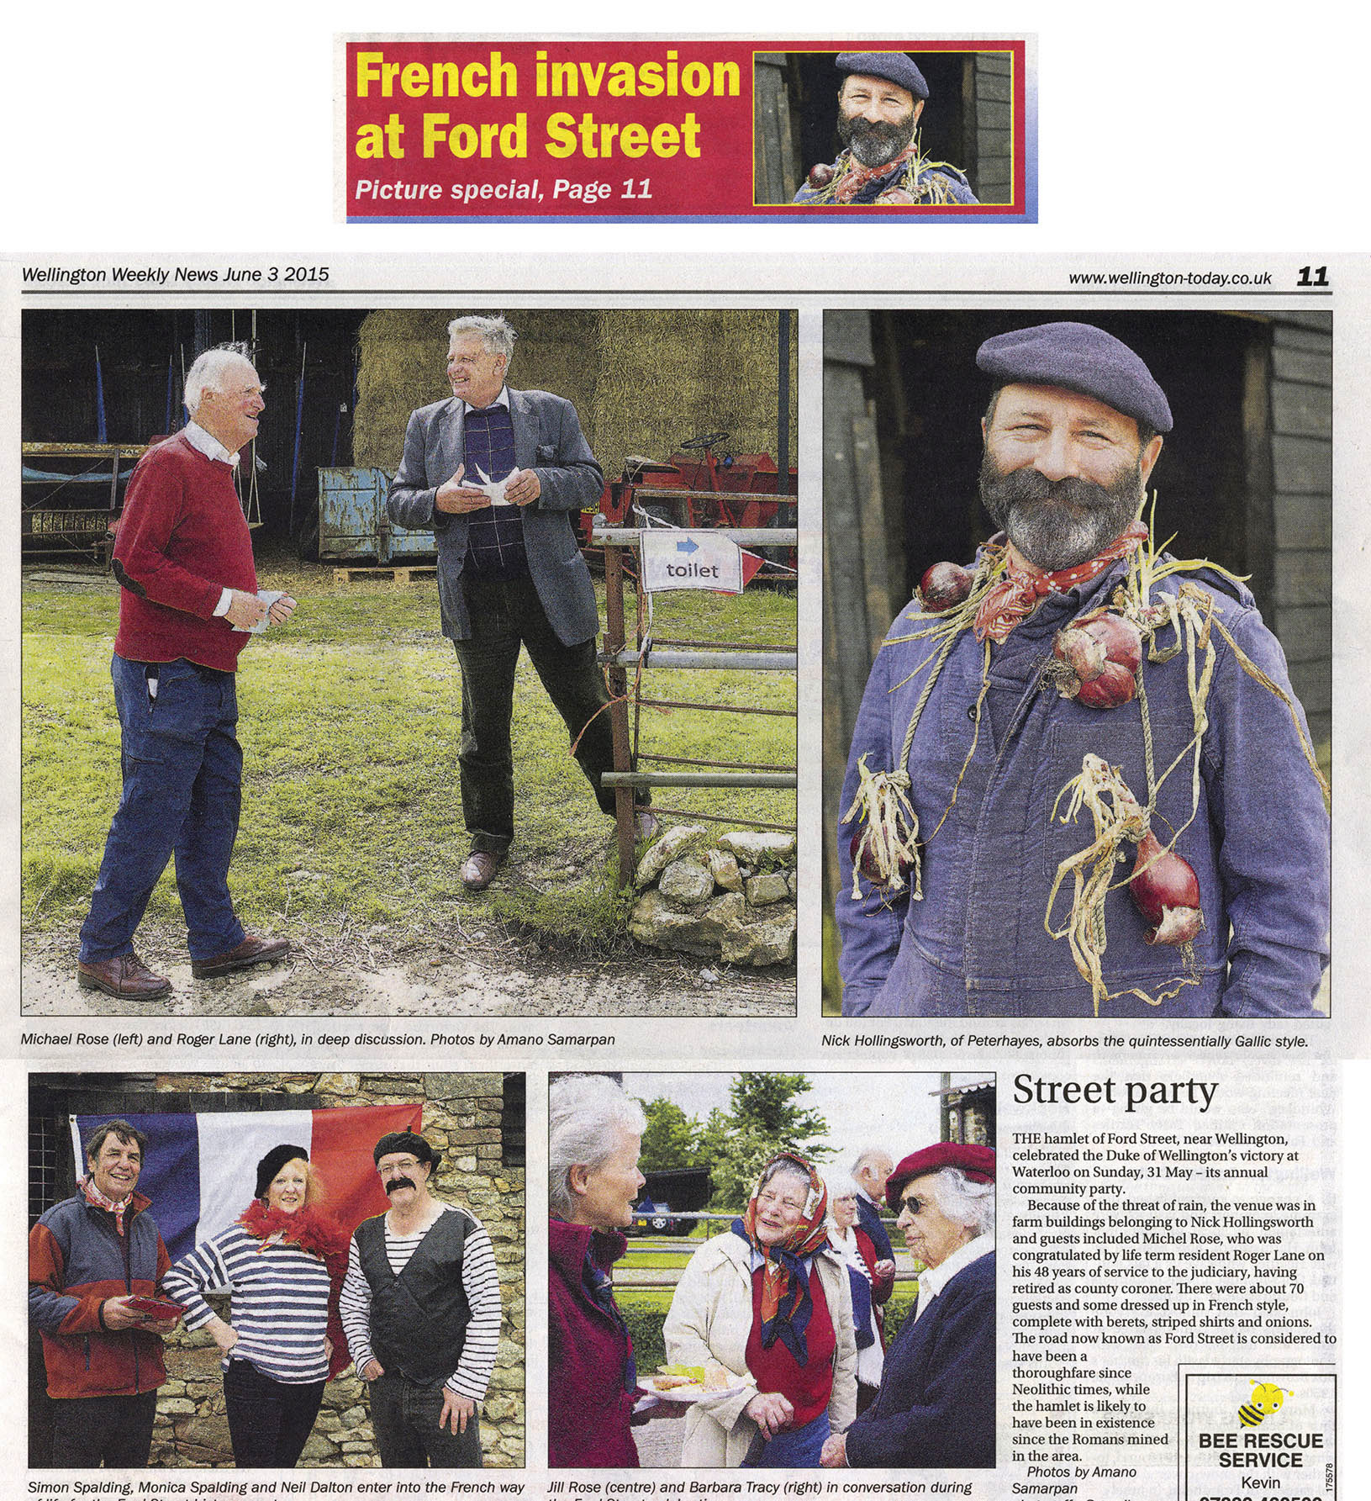

Excerpt from the Wellington Weekly News on June 3rd 2015