Community Speedwatch

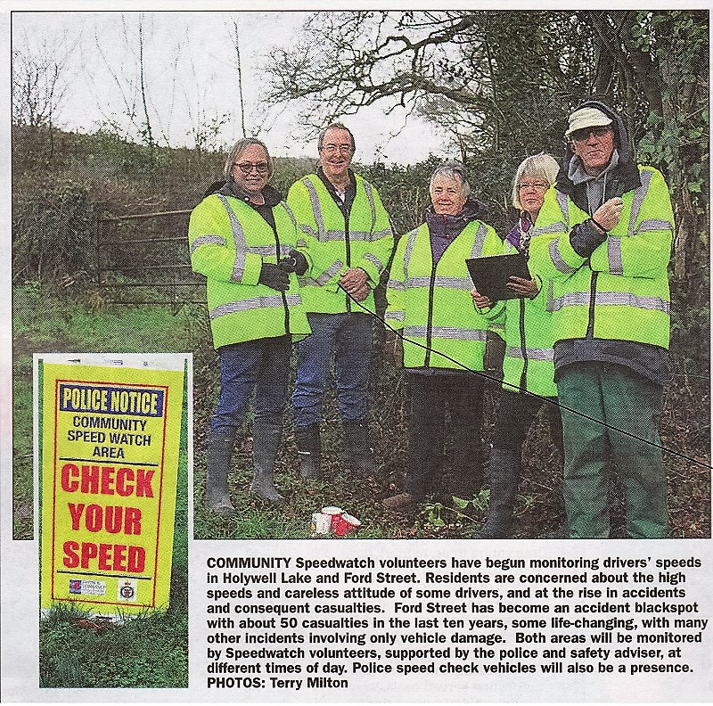

Extract from the Wellington Weekly February 18th 2016