LORNA DOONE

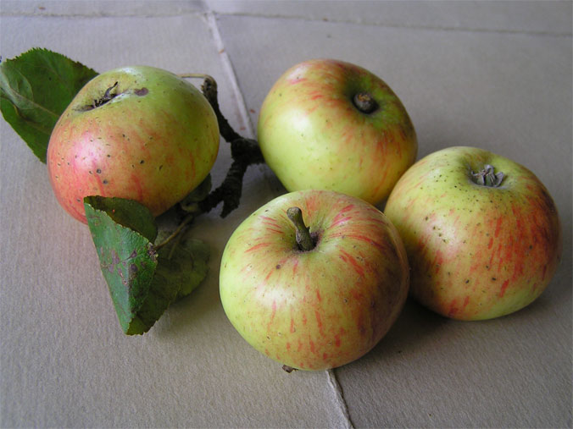

The Lorna Doone cider apple supposedly originated in the cider orchard belonging to the Lorna Doone Cider Factory at Ford Street.

Although not extant in the hamlet at present it was found in the old orchard at Stubbs Farm, Monkton Wylde as Tree X in 2007 and it is hoped to reintroduce it to its original site in the future.

It is a large, flattened conical apple with a broad base and nose, and rather ribbed; yellow-green with red stripes from the stem basin, becoming fainter towards the nose.

It is ready from late October to early November and is classified as a “late, mild sharp” apple.