The Island planning application (date unknown)

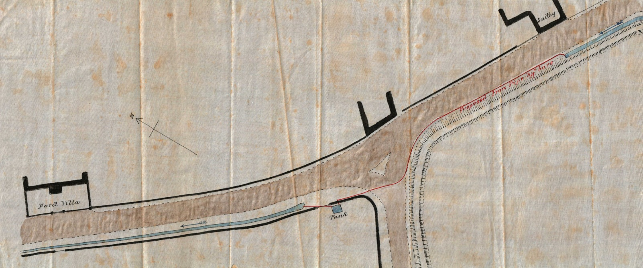

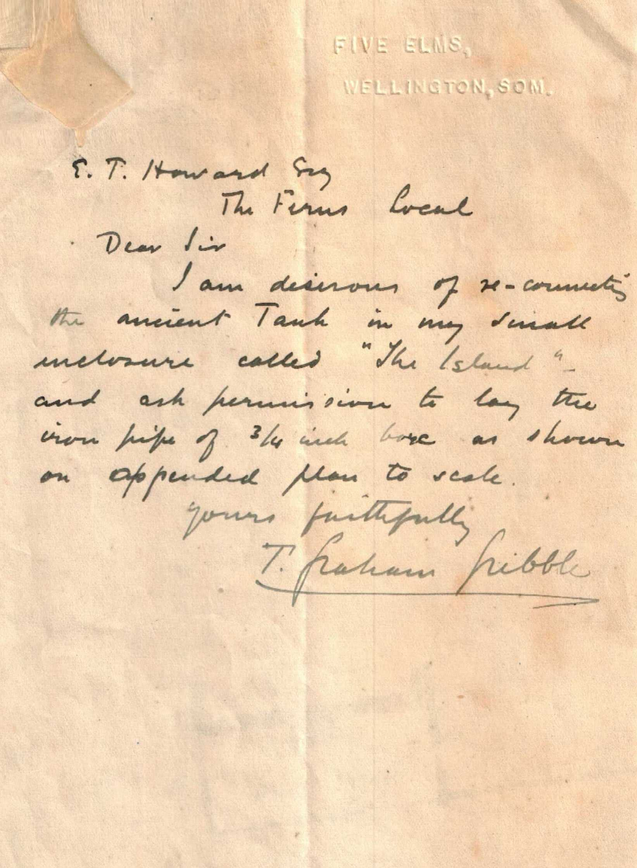

Note that Mr Gribble lived at Five Elms, but owned the land still known today as The Island, at one time the site of the Rising Sun Public House.