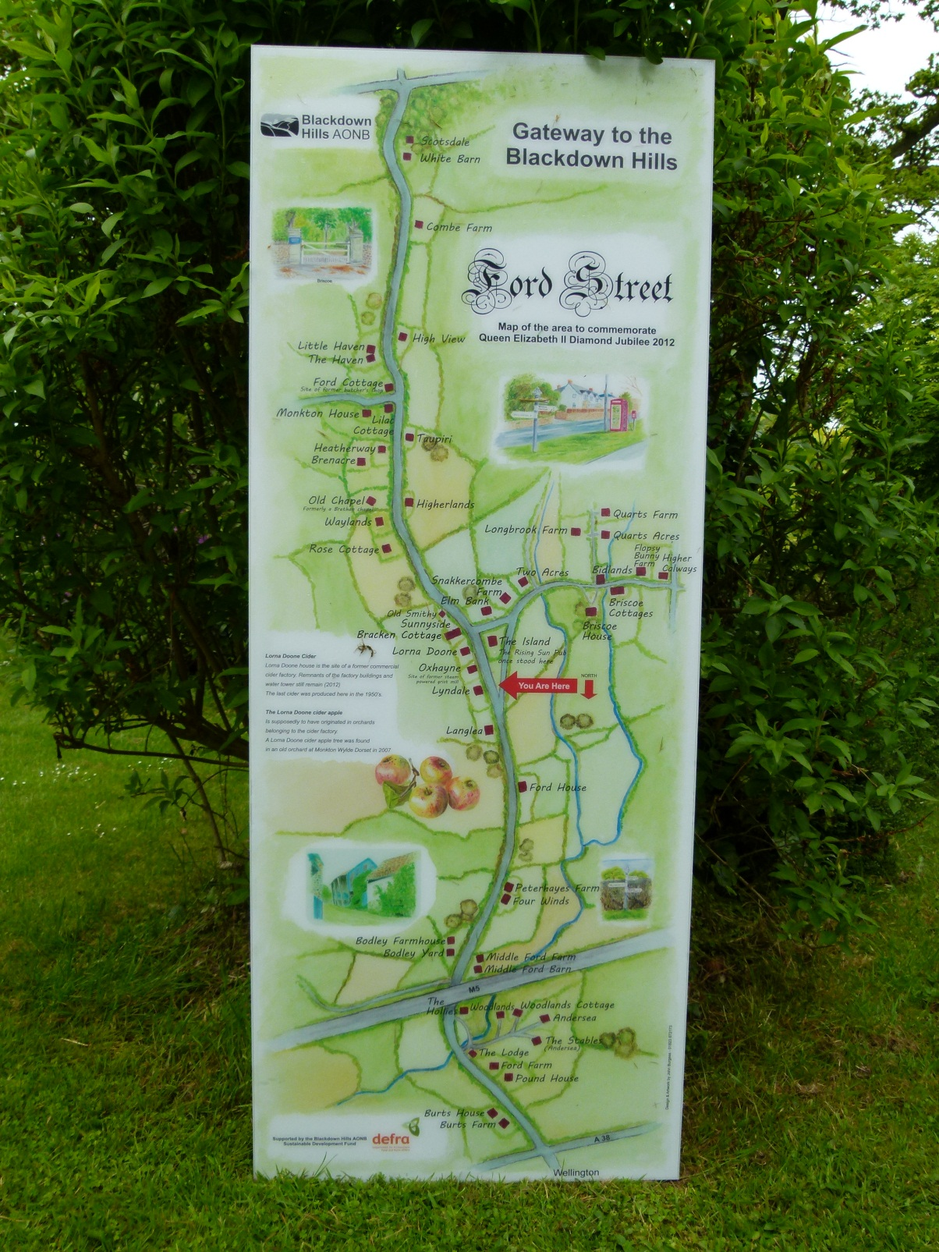

This map can be found on the back of the old telephone kiosk and was specially commissioned from John Burgess, a local artist. All the properties on Ford Street and the immediately surrounding area can be found in addition to some illustrated history of the hamlet.