Ford Farm and the Wellington bread riots of 1846

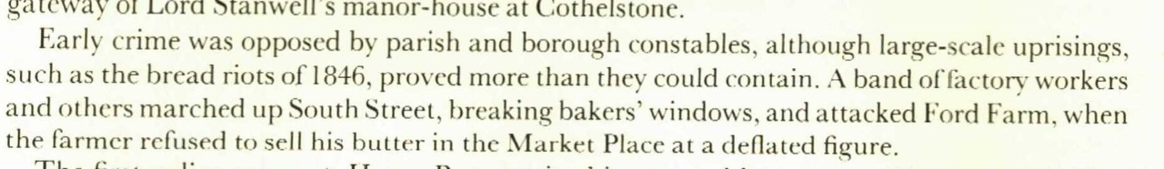

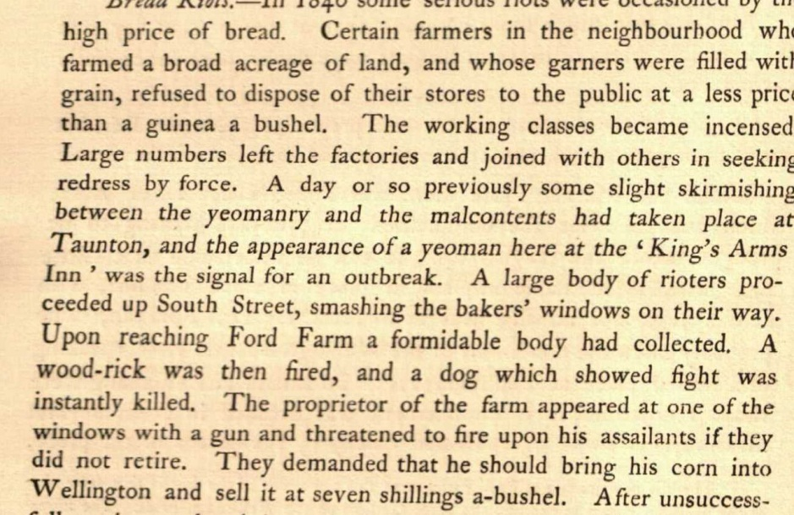

Fire at Ford Farm in 1889

