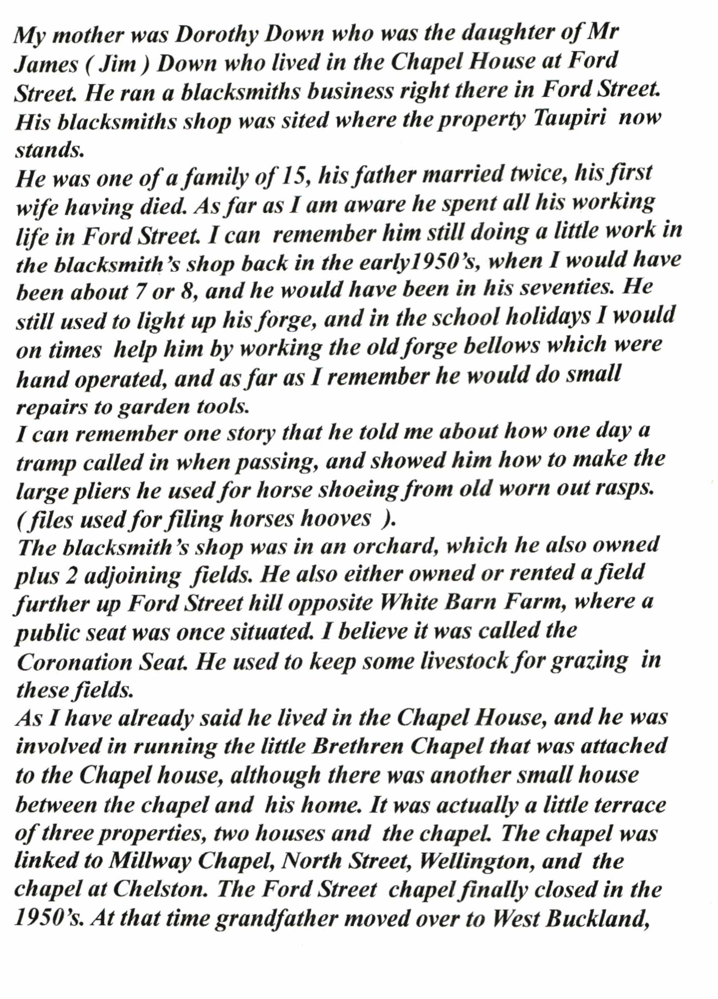

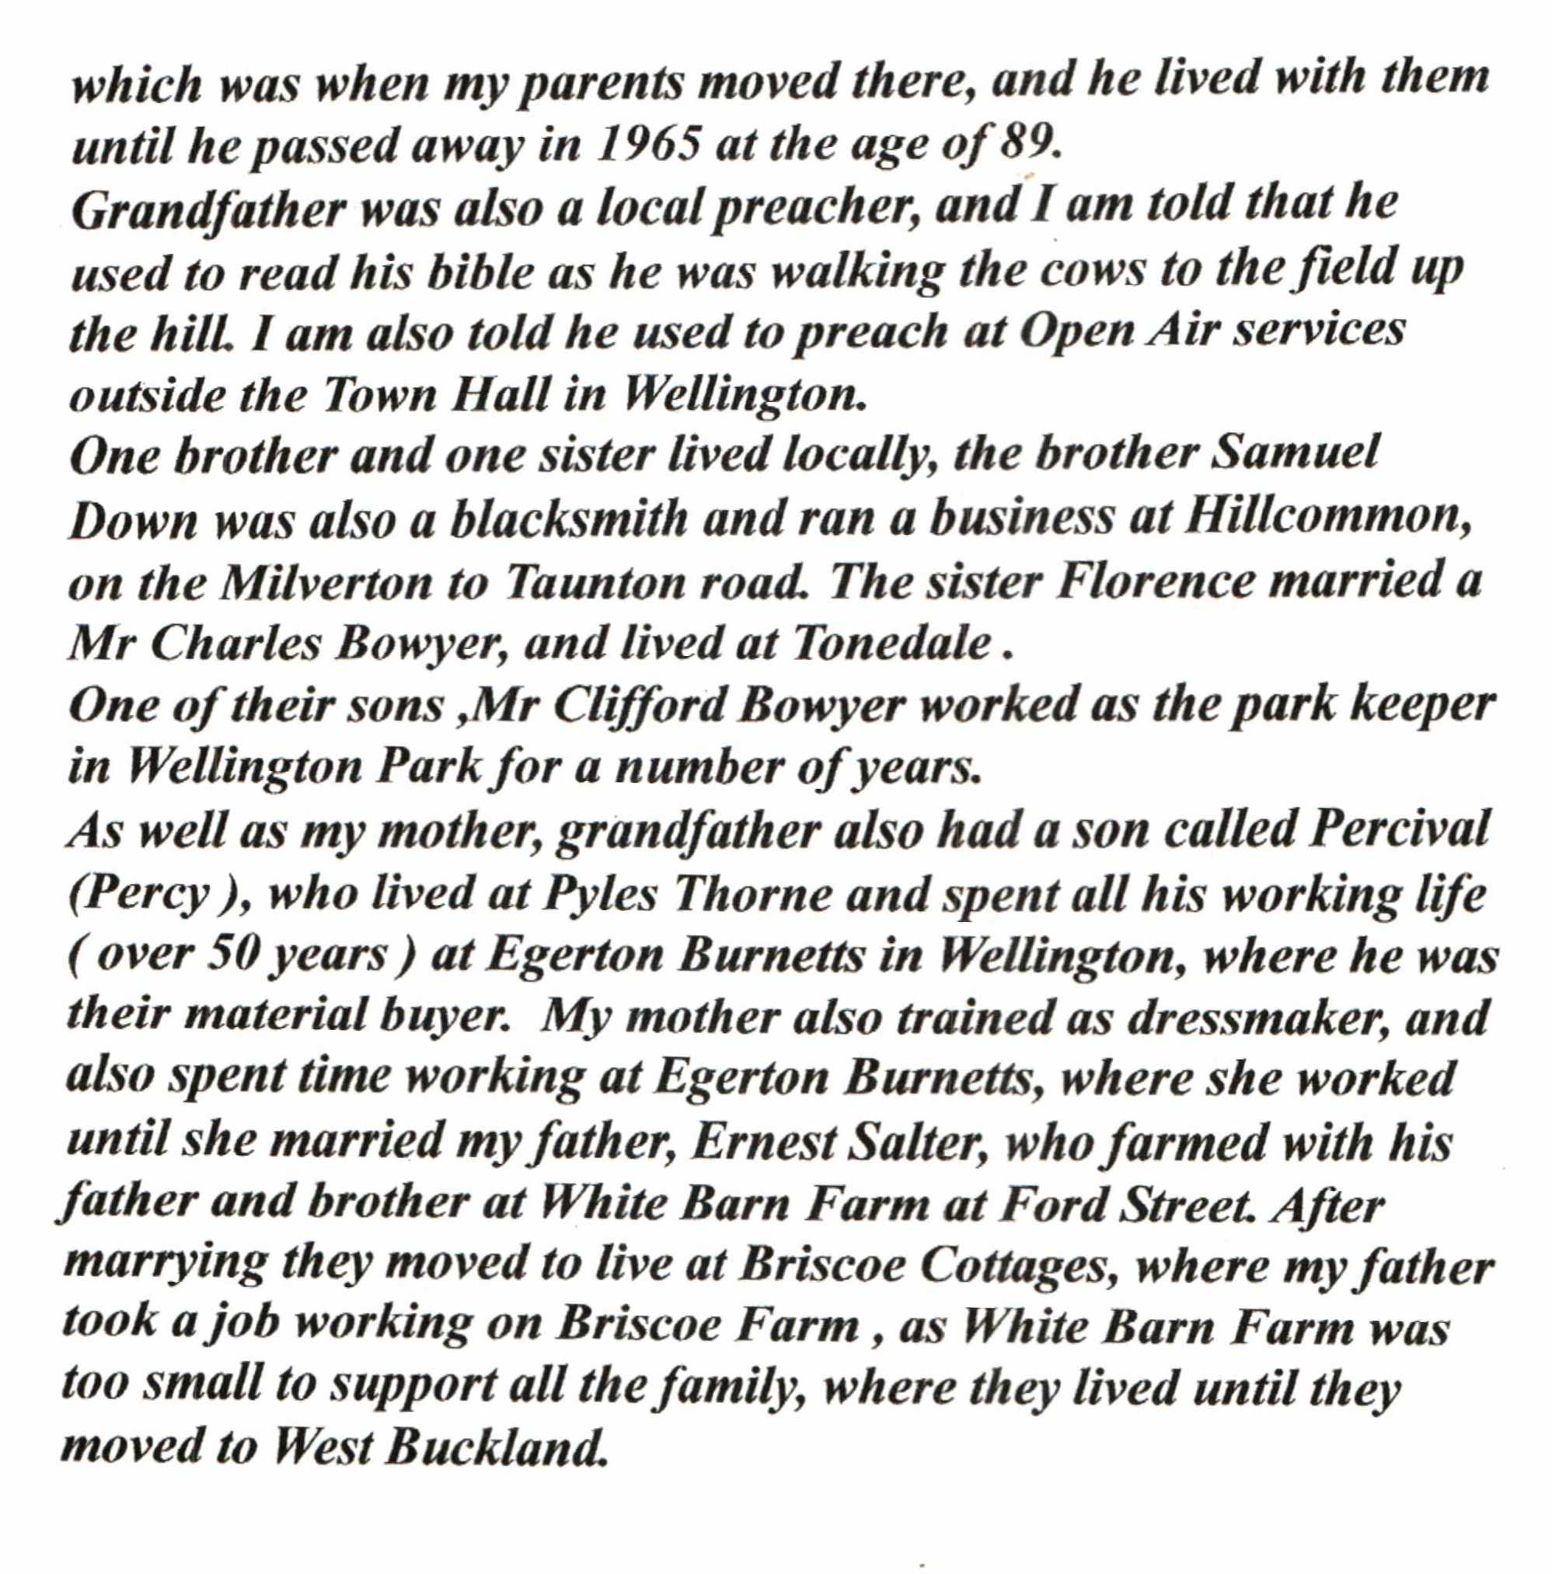

Written by John Salter, who retains the copyright, and who has given permission for this to be reproduced on the Ford Street Website